AI-Assisted Pharmacovigilance via Multi-Source Data Integration:
A Comparative Safety Signal Analysis of Semaglutide and Sertraline
Author: Sharath kasula,¹ MS Health Data Science
Co-author: Melinda B. Chu,² M.D., M.B.

Abstract
Pharmacovigilance is crucial in the safety surveillance of drugs outside the clinical trial, especially in discovering adverse drug events (ADE) that may arise in the real world. The conventional methods of pharmacovigilance can oftentimes use only one source of data, which restricts the possibility to capture the complete safety profile of drugs. This research paper suggests a multi-source AI-based pharmacovigilance system that consolidates the openFDA (FAERS), DailyMed, ClinicalTrials.gov, and PubMed adverse event data.
The comparison is on semaglutide and sertraline, which depict different classes of therapy. An organized scoring system is presented to measure agreement and disagreement among the sources. The agreement scores provide the well-established adverse events that have been reported in all sources of data whereas divergence scores provide the discrepancy especially where real world data has signaled the presence of an adverse event that is not well represented in the clinical trials or regulatory labeling. Also, an AI-based interpretation layer is applied to create structured safety pattern summaries. This framework improves pharmacovigilance by facilitating the detection and interpretability of signals by integrating multi-source data.¹⁻⁴

1. Introduction
The process of identifying, evaluating, interpreting, and preventing adverse drug reactions and other issues is called pharmacovigilance. Although pre-marketing clinical trials determine the baseline safety profiles, they are also limited inherently by control conditions, relatively small sample sizes and limited follow-up periods. Consequently, numerous adverse drug events are not noticed until numerous clinical uses occur.⁵

There are various publicly available data used in modern pharmacovigilance. New FDA Adverse Event Reporting System (FAERS) available through openFDA records spontaneous real-world adverse event reports. But the FDA makes it plain that these reports do not establish causality and are subject to underreporting and bias.¹⁶ DailyMed contains the most up-to-date FDA-approved drug labeling, reflecting regulatory expertise on drug safety.² ClinicalTrials.gov contains clinical trial data in a structured format and adverse events are reported where available.³ PubMed is biomedical literature providing clinical interpretation and supporting evidence.⁴

Although such sources are available, they are frequently examined separately and give piecemeal information. This paper is filling this gap with an umbrella approach to multiple sources that would create a single pharmacovigilance system that compares the pattern of adverse events systematically across domains of evidence.¹⁵

2. Objectives
The main purpose of the research was to create a versatile, AI-based pharmacovigilance system combining various publicly available data on adverse events to assess the trends of semaglutide and sertraline. The specific objectives are:
- To extract adverse event data from openFDA, DailyMed, ClinicalTrials.gov, and PubMed.
- To harmonize drug names and adverse event terminology across sources.
- To develop a scoring system measuring agreement and divergence across data sources.
- To identify well-established and emerging safety signals.
- To implement an AI-assisted interpretation layer to summarize findings.

3. Methodology

3.1 Study Design
This study employs a comparative observational design using publicly available secondary data. No patient-level protected health information is used, ensuring ethical compliance.

3.2 Drug Selection
Two drugs were selected:
- Semaglutide
- Sertraline
These drugs represent distinct therapeutic classes, allowing evaluation of the framework across different adverse event domains.²³

3.3 Data Sources

openFDA / FAERS
Provides real-world adverse event reports. These data are useful for signal detection but are subject to underreporting, duplicate reporting, and reporting bias.¹⁶

DailyMed
Contains current FDA-approved labeling, including adverse reactions and warnings, representing regulatory knowledge of drug safety.²

ClinicalTrials.gov
Provides structured clinical trial data, including adverse event reporting when results are available. However, trial populations may not fully represent real-world populations.³⁹

PubMed
Provides biomedical literature, including clinical studies and reviews. This source supports interpretation but may be affected by publication bias.⁴¹³

3.4 Data Harmonization
Adverse event terminology differs across sources. Therefore, a canonical event dictionary was created to standardize terminology.
For example:
- “Vomiting” and “emesis” → same category
- “Sexual dysfunction” → grouped with libido-related terms
Drug names were also standardized to account for brand and generic variations. This step was critical to ensure valid cross-source comparisons.¹⁵

3.5 Scoring Framework

Agreement Score
Each adverse event is assigned a score from 0–4 based on its presence across:
- openFDA
- DailyMed
- ClinicalTrials.gov
- PubMed
Interpretation:
- 4 = Strong agreement
- 3 = High support
- 2 = Moderate evidence
- 0–1 = Weak evidence

Divergence Score
Measures discrepancies across sources, particularly:
- High FAERS reporting
- Low presence in trials or labels
Such divergence may indicate:
- Emerging safety signals
- Underreported risks
However, FAERS data should not be interpreted as causal evidence.¹⁶

3.6 Source Strength Classification
Each source is further categorized:
- FAERS: Reporting frequency
- DailyMed: Label section (boxed warning, precautions, adverse reactions)
- ClinicalTrials.gov: Serious vs non-serious events
- PubMed: Evidence type (meta-analysis, observational, case reports)
This layered approach enhances analytical depth.⁹

3.7 AI-Assisted Interpretation
A lightweight AI layer generated structured summaries of findings. Instead of predictive modeling, the AI component focused on interpretation:
- “Well-established adverse effect”
- “Label-supported and expected”
- “Real-world prominent but underrepresented in trials”
This improves interpretability while maintaining methodological rigor.¹⁷

4. Results
The completed analysis identified distinct multi-source safety patterns for semaglutide and sertraline using both full filtered tables and higher-confidence source-overlap subsets.
- Semaglutide yielded 827 filtered normalized adverse-event terms with agreement score 0.046 and divergence score 0.954. Its higher-confidence subset contained 38 terms supported by at least two sources.
  - Its strongest multi-source terms were vomiting, diarrhea, constipation, weight loss, abdominal pain, fatigue, headache, abdominal pain upper, dizziness, and dyspepsia. Twelve semaglutide terms achieved support from three or more sources, with no four-source term retained in the latest filtered output.

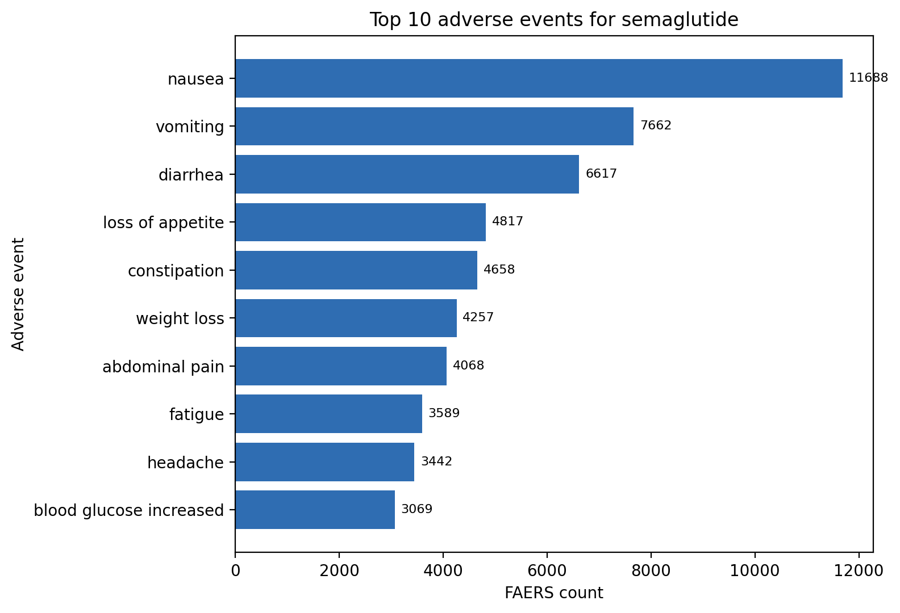
Fig-1
- Sertraline yielded 389 filtered normalized adverse-event terms with agreement score 0.082 and divergence score 0.918. Its higher-confidence subset contained 32 terms supported by at least two sources.
  - Its strongest multi-source terms were nausea, anxiety, insomnia, fatigue, headache, dizziness, vomiting, tremor, and drowsiness. Nine sertraline terms achieved support from three or more sources, and nausea, anxiety, and insomnia each achieved full four-source agreement.

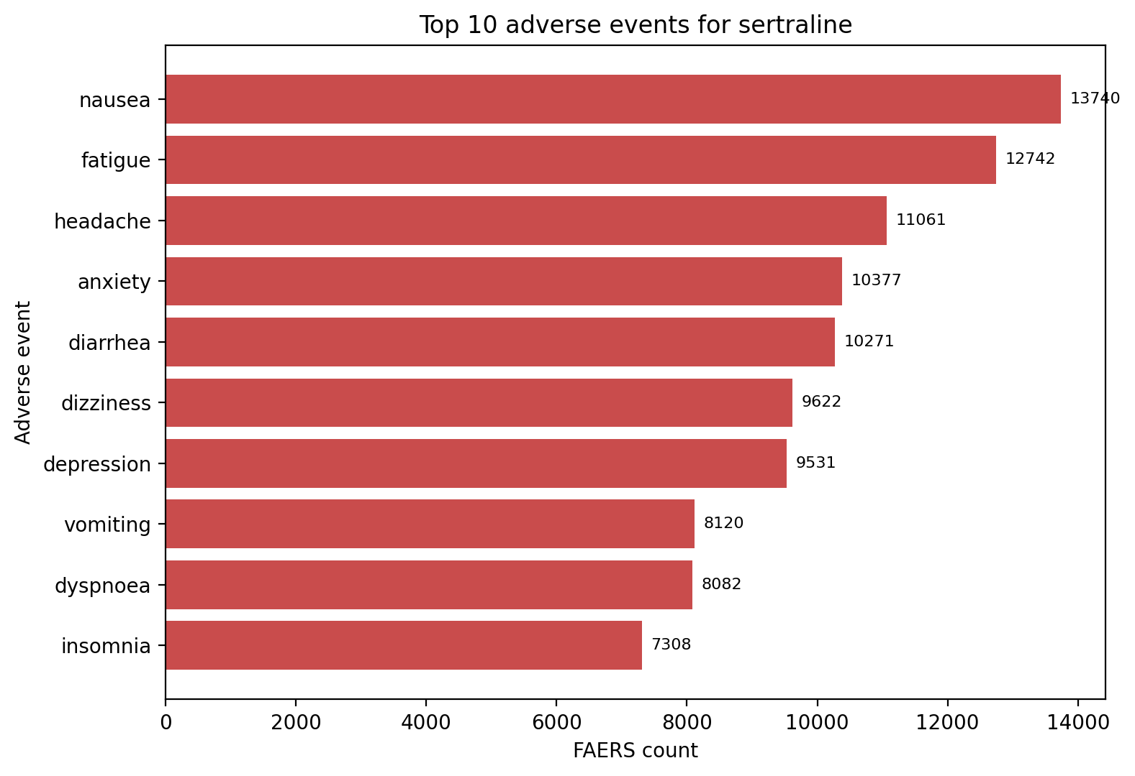
Fig-2

- Both drugs retained high divergence, indicating that most terms remained source-specific across FAERS, DailyMed, ClinicalTrials.gov, and PubMed even after normalization and filtering of non-clinical FAERS entries.
  - The comparison therefore identified a concentrated gastrointestinal and upper-gastrointestinal profile for semaglutide and a broader neuropsychiatric and autonomic profile for sertraline.
  - These results show that the pipeline can recover clinically plausible core signals while also highlighting structural differences between evidence sources.
The strongest agreement signals appear to reflect established adverse effects, whereas the remaining divergence is driven by source-specific reporting, differing evidence coverage, and terminology variation.¹⁰

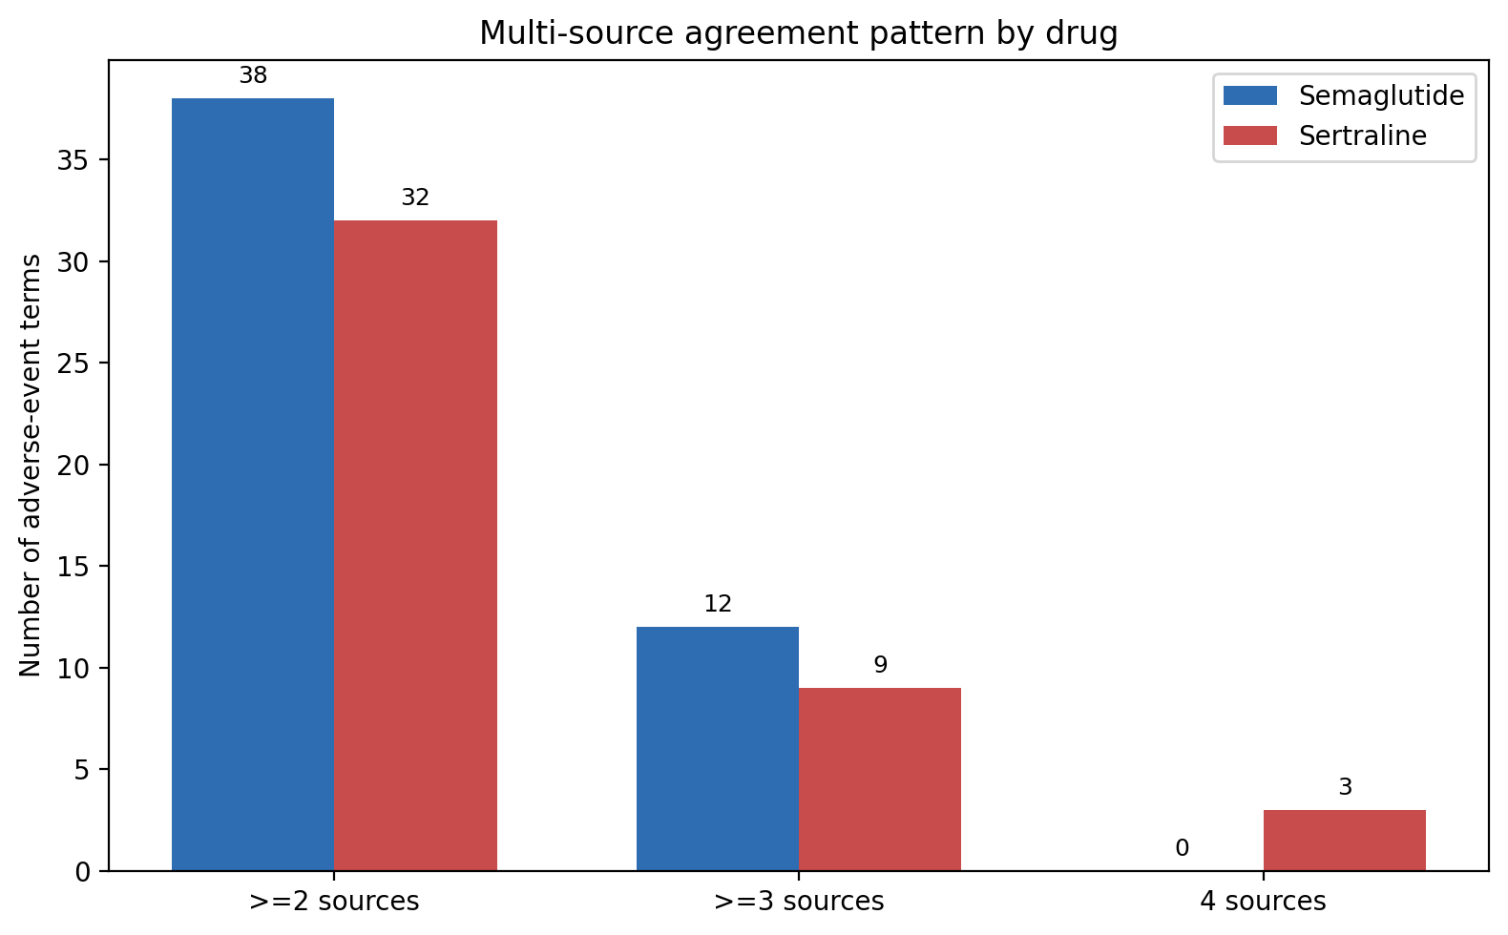

Fig-3

5. Discussion
The most recent filtered output revealed that sertraline had greater cross-source agreement than semaglutide, but both treatments were still characterized by source-specific words. This trend is in line with the varying contributions of spontaneous reports, regulatory labeling, posting of trial results and published literature.
- For semaglutide, limited ClinicalTrials.gov result coverage and sparse PubMed overlap reduced the number of high-support terms even though a coherent gastrointestinal cluster remained clearly visible across FAERS, DailyMed, and many trial-result records.
- For sertraline, several adverse events were supported across three or four sources, suggesting stronger convergence for a subset of common SSRI-related symptoms such as nausea, anxiety, insomnia, tremor, and drowsiness.
- FAERS-only administrative or non-clinical entries initially inflated divergence scores, which is why the filtering and normalization steps were essential to produce interpretable symptom-level tables and the additional high-quality tables restricted to terms with support from at least two sources.
- These findings do not establish causality, but they show that multi-source integration improves interpretability compared with single-source safety review.

The framework is scalable and can be expanded to other drugs or enhanced with more detailed ontology mapping, wider literature term extraction, and more cover of trial-results.¹⁷

6. Limitations
Several limitations must be considered:
- FAERS data are subject to reporting bias and do not establish causality¹⁶
- DailyMed reflects current labeling but may not capture emerging signals²
- ClinicalTrials.gov data may be incomplete³
- PubMed literature may exhibit publication bias⁴
These limitations justify the need for a multi-source framework.

7. Conclusion
The work provides a solid AI-based pharmacovigilance system that combines several publicly available data sources to measure drug safety. Comparing semaglutide and sertraline illustrates the variability in adverse events patterns in real-world reports, regulatory labeling, clinical trials, and literature and how this variability can be summarised using agreement, divergence and high-quality overlap tables. The framework improves the pharmacovigilance by systemizing the heterogenous public evidence into interpretable cross-source safety profiles, which underpin evidence-based review.¹⁷
References
- U.S. Food and Drug Administration. FDA Adverse Event Reporting System (FAERS).
Available at: https://www.fda.gov/drugs/fda-adverse-event-reporting-system-faers
Accessed April 23, 2026.
- U.S. Food and Drug Administration. Questions and Answers on FAERS.
Available at: https://www.fda.gov/drugs/surveillance/faers
Accessed April 23, 2026.
- World Health Organization. The Importance of Pharmacovigilance: Safety Monitoring of Medicinal Products. Geneva: WHO; 2002.
Available at: https://apps.who.int/iris/handle/10665/42493
- International Council for Harmonisation. E2E Pharmacovigilance Planning Guideline. 2004.
Available at: https://database.ich.org/sites/default/files/E2E_Guideline.pdf
- Sakaeda T, Tamon A, Kadoyama K, Okuno Y. Data mining of the public version of the FDA Adverse Event Reporting System. Int J Med Sci. 2013;10(7):796–803.
doi:10.7150/ijms.6048
Link: https://doi.org/10.7150/ijms.6048
- Bate A, Evans SJ. Quantitative signal detection using spontaneous ADR reporting. Pharmacoepidemiol Drug Saf. 2009;18(6):427–436.
doi:10.1002/pds.1742
Link: https://doi.org/10.1002/pds.1742
- Hazell L, Shakir SA. Under-reporting of adverse drug reactions: a systematic review. Drug Saf. 2006;29(5):385–396.
doi:10.2165/00002018-200629050-00003
Link: https://doi.org/10.2165/00002018-200629050-00003
- ClinicalTrials.gov. Results Data Element Definitions.
Available at: https://clinicaltrials.gov/policy/results-definitions
- Ioannidis JP. Why most clinical research findings are false. PLoS Med. 2005;2(8):e124.
doi:10.1371/journal.pmed.0020124
Link: https://doi.org/10.1371/journal.pmed.0020124
- Eichler HG, Abadie E, Breckenridge A, et al. Bridging the efficacy–effectiveness gap. Nat Rev Drug Discov. 2011;10(7):495–506.
doi:10.1038/nrd3501
Link: https://doi.org/10.1038/nrd3501
- DailyMed. DailyMed Drug Label Information.
Available at: https://dailymed.nlm.nih.gov
- Goldman SA. Limitations and strengths of spontaneous reports data. Clin Ther. 1998;20 Suppl C:C40–C44.
doi:10.1016/S0149-2918(98)80012-5
Link: https://doi.org/10.1016/S0149-2918(98)80012-5
- National Center for Biotechnology Information. Entrez Programming Utilities Help.
Available at: https://www.ncbi.nlm.nih.gov/books/NBK25501
- Lu Z. PubMed and beyond: a survey of web tools for biomedical literature search. Database (Oxford). 2011;2011:baq036.
doi:10.1093/database/baq036
Link: https://doi.org/10.1093/database/baq036
- Banda JM, Seneviratne M, Hernandez-Boussard T, Shah NH. Advances in electronic phenotyping. J Am Med Inform Assoc. 2018;25(10):1355–1363.
doi:10.1093/jamia/ocy069
Link: https://doi.org/10.1093/jamia/ocy069
- Harpaz R, DuMouchel W, Shah NH, et al. Novel data-mining methodologies for adverse drug event discovery. Clin Pharmacol Ther. 2012;91(6):1010–1021.
doi:10.1038/clpt.2012.50
Link: https://doi.org/10.1038/clpt.2012.50
- Tatonetti NP, Ye PP, Daneshjou R, Altman RB. Data-driven prediction of drug effects and interactions. Sci Transl Med. 2012;4(125):125ra31.
doi:10.1126/scitranslmed.3003377
Link: https://doi.org/10.1126/scitranslmed.3003377
- Semaglutide prescribing information. DailyMed.
Available at: https://dailymed.nlm.nih.gov
- Marso SP, Bain SC, Consoli A, et al. Semaglutide and cardiovascular outcomes in patients with type 2 diabetes. N Engl J Med. 2016;375:1834–1844.
doi:10.1056/NEJMoa1607141
Link: https://doi.org/10.1056/NEJMoa1607141
- Sertraline prescribing information. DailyMed.
Available at: https://dailymed.nlm.nih.gov
- Ferguson JM. SSRI antidepressant medications: adverse effects and tolerability. J Clin Psychiatry. 2001;62 Suppl 22:22–34.
Link: https://pubmed.ncbi.nlm.nih.gov/11434438

